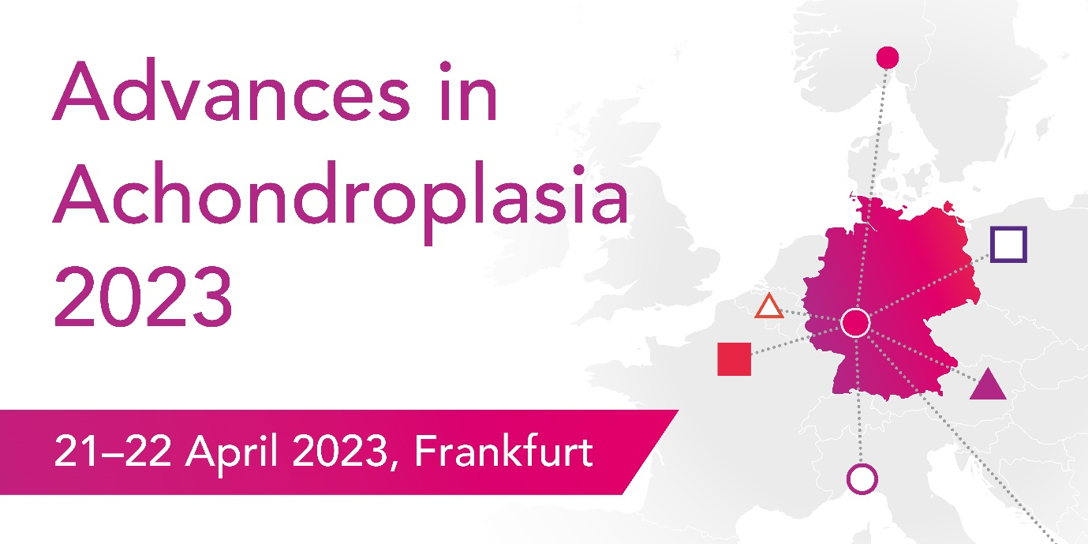

Chair’s Highlights

Professors Geert Mortier and Mohamad Maghnie

- The opinions of individuals with achondroplasia are vital to ensure healthcare professionals understand what is important
  - It is important to use the right language – achondroplasia is a condition, not a disease!
  - Providing information to people with achondroplasia, and opportunity for participation in events such as this is very important
- Advances in Achondroplasia has provided:
  - Information sharing on new products in the pipeline, and in practice
  - Emphasis on the importance of multidisciplinary care, through the lifespan
  - Identification of key gaps in the management of achondroplasia, including at the point of transition to adult care, and mental health support
- Creating links between expertise in secondary and tertiary care to primary care will be vital to supporting adults with achondroplasia
- More data is needed to progress the management of achondroplasia, including:
  - Data on the natural history of achondroplasia
  - Patient monitoring data
  - Need for international consensus on monitoring protocols for treatment options

